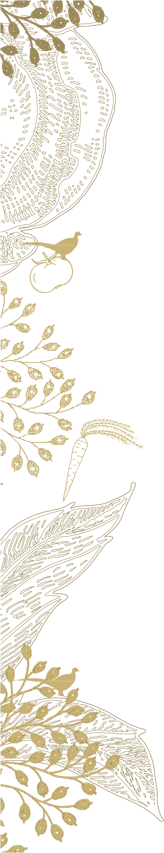

Starters
Prawn Cocktail
Tomato, Avocado, Baby Gem Lettuce & Marie Rose Sauce

Butternut Squash & Thyme Soup
Toasted Pumpkin Seeds & Warm Crusty Focaccia

Smoked Haddock & Poached Egg
Wilted Spinach & Truffle Butter

Pen-Y-Lan Black Pudding & Crushed New Potatoes
Wholegrain Chicken Jus & Chives

Pickled Beetroot, Goats Cheese & Horseradish
Watercress, Kohlrabi & Herb Oil

Mains
Roast Chicken Breast
Peas, Bacon and Charred Baby Gem

Pen-Y-Lan Pork Sausages
Cumin & Spring Onion Potato Salad & Balsamic Jam

Pumpkin and Porcini Risotto
Crispy Sage

Beer Battered Fillet of Hake
Chips, Crushed Minted Peas, Tartare Sauce

Beef Burger & Monterey Jack Cheese
Rocket Mayonnaise, Beef Tomato, Onion Ring on a Brioche Bun & Fries

Pan Fried Fillet of Salmon
Grilled Asparagus, Poached Egg & Bearnaise Sauce

250g Ribeye Steak
Confit Tomato, Grilled Mushroom, Pickled Red Onion & Watercress Salad & Chips
(Supplement £6)

Pan Fried Fillet of Cod
Pistachio & Sage Beurre Noisette, Baby Spinach & Black Truffle
(Supplement £6)

Side Orders
All £3.50
Tender stem Broccoli
Thyme & Garlic Baby Potatoes
Charred Asparagus
Peppercorn Sauce
Fries

Please advise a member of our team if you have any allergies or dietary requirements.

